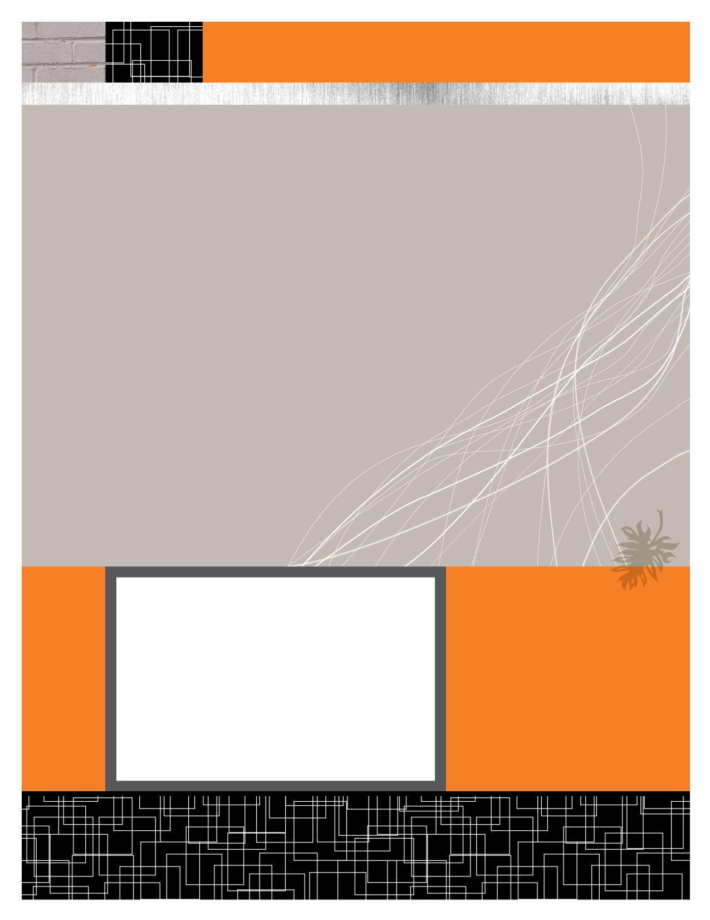

Anshul Jain (Y09UC027)

Mumal Seth (Y09UC086)

Shreya Mundra (Y09UC150)

Karan Poddar (Y09UC301)

Course Registration Portal

Data Flow Diagrams (DFD’s)

February 22, 2012

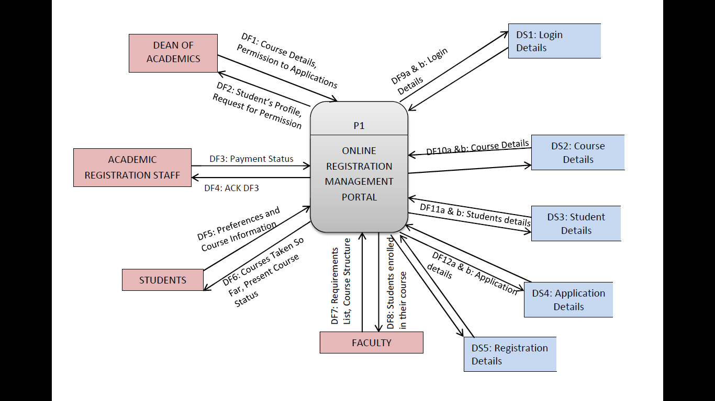

CONTEXT DIAGRAM

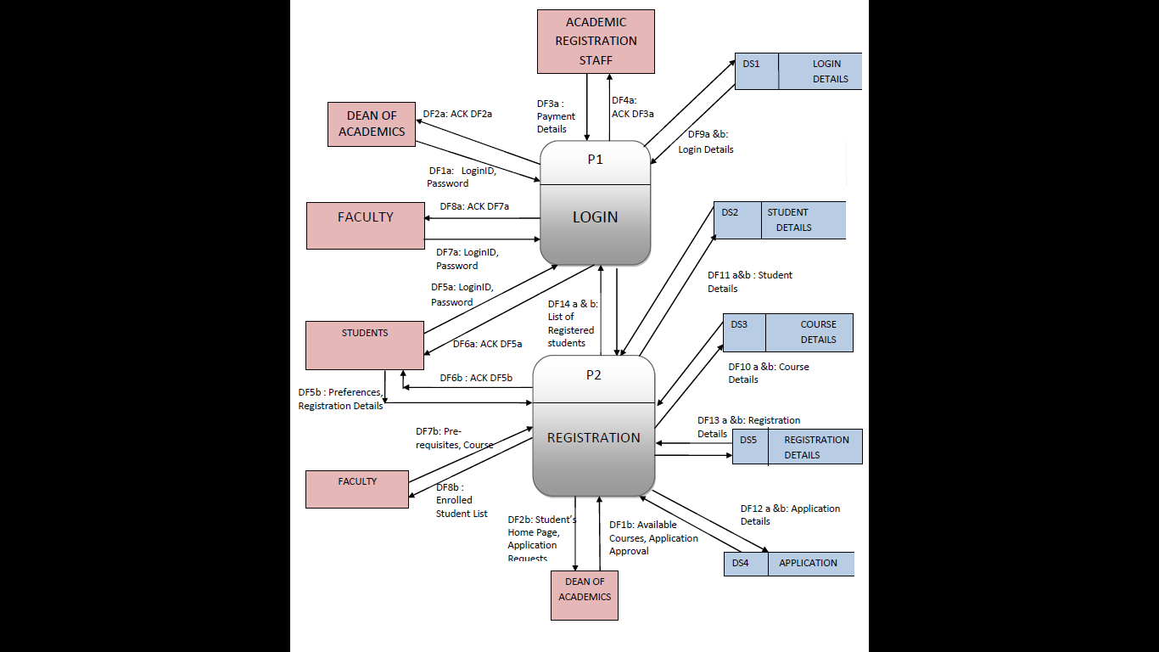

LEVEL 1

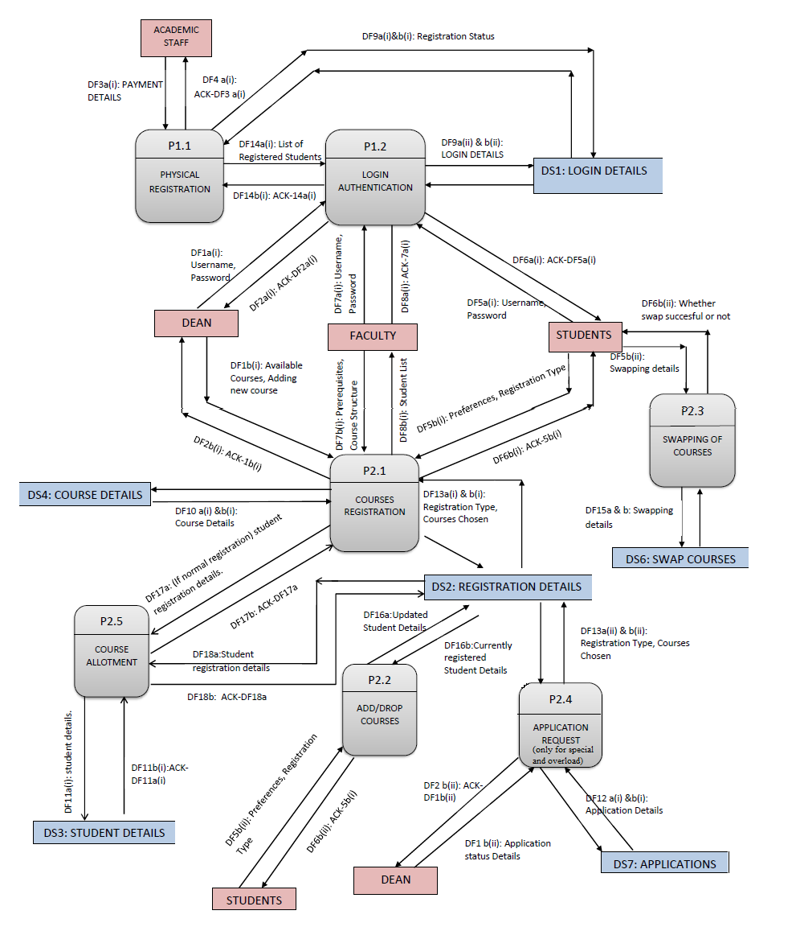

DF19a & b: Updated Student Details

LEVEL 2